SpendWise: A Simple Backend Learning Project
Ideation Phase
Brainstorm & Idea Prioritization

Date | 08 March 2026
Team ID | SWTID-2026-7798
Project Name | SpendWise
Maximum Marks | 4 Marks

Brainstorm & Idea Prioritization Template:
Brainstorming is a collaborative technique where participants freely express their ideas in order to find solutions to a problem. For SpendWise, the objective is to develop practical and easy-to-understand ideas that support students in learning backend development. Initially, every idea is recorded without evaluation. Afterwards, the ideas are categorized and prioritized according to their relevance and suitability for beginners.

Step-1: Team Gathering, Collaboration and Select the Problem Statement

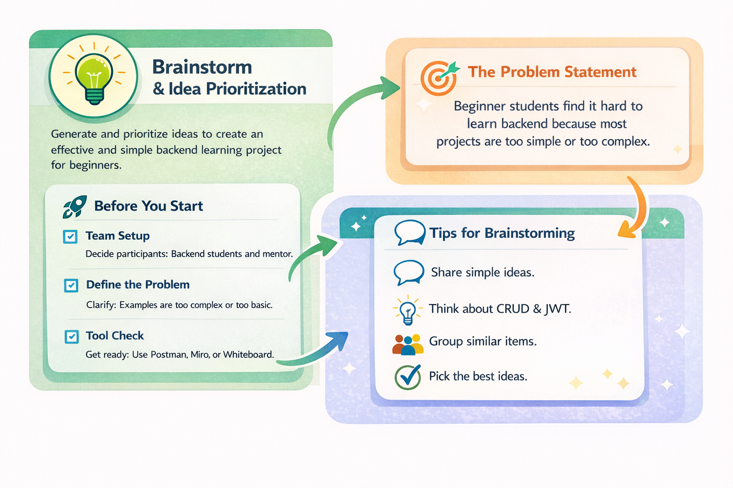

Step-2: Brainstorm, Idea Listing and Grouping
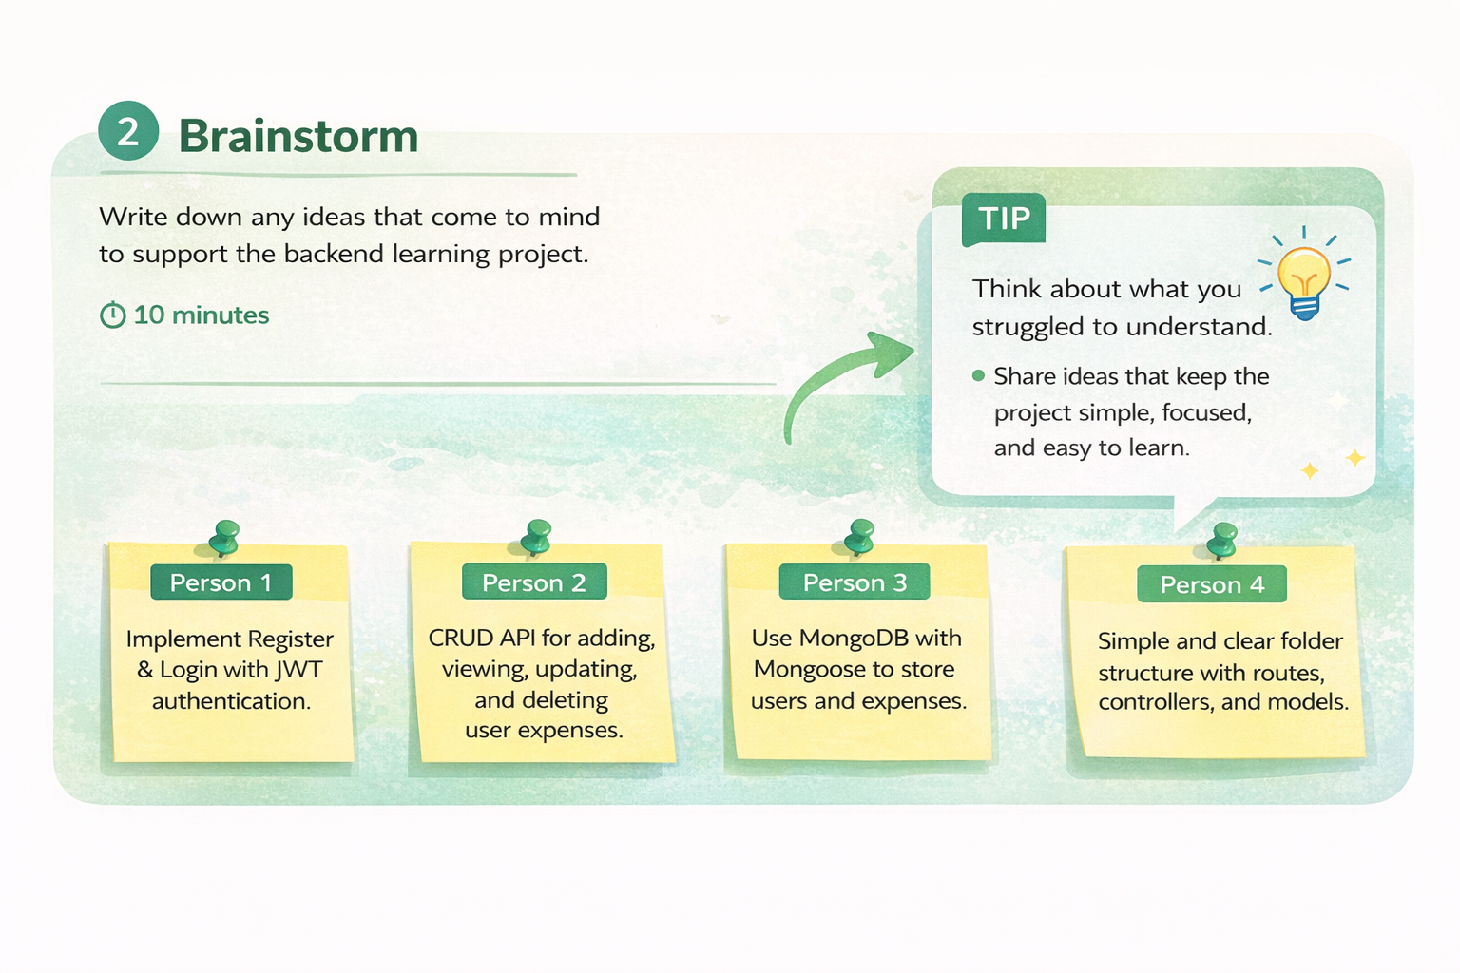

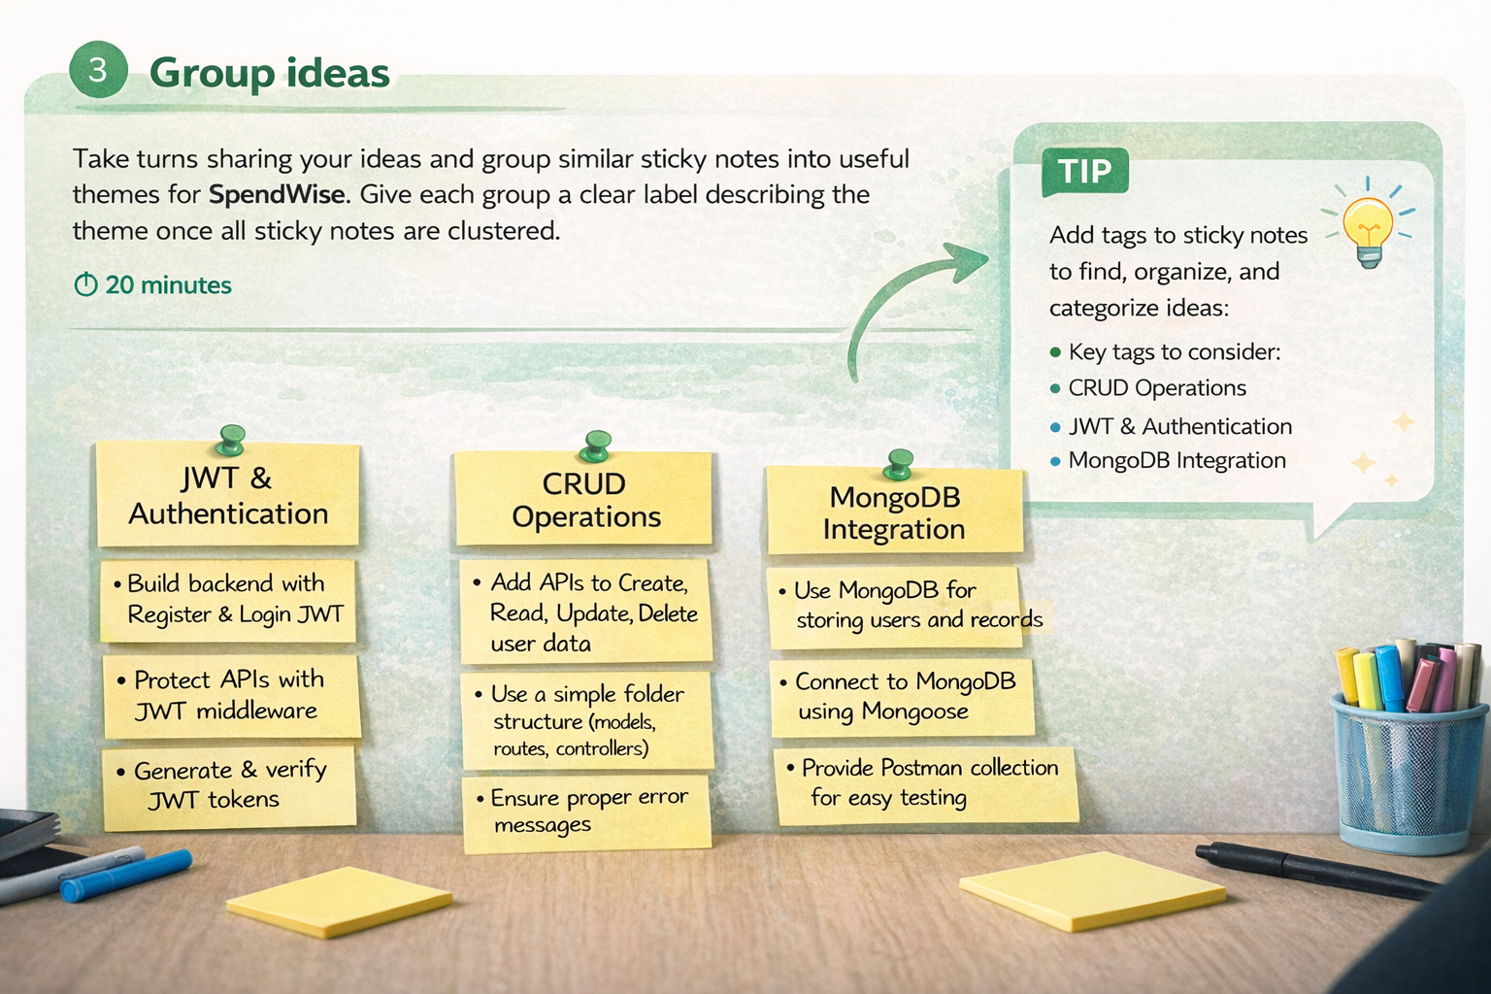

Step-3: Idea Prioritization
